Museums Australia (Victoria) 2007

FORWARD PLAN TEMPLATE

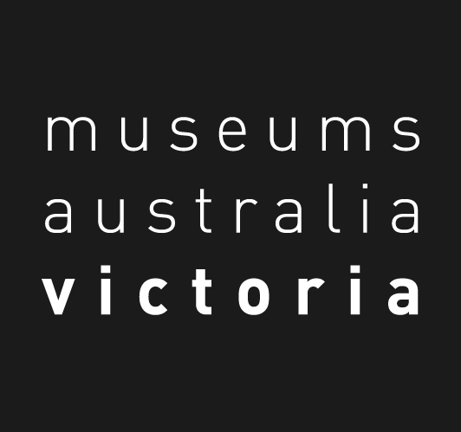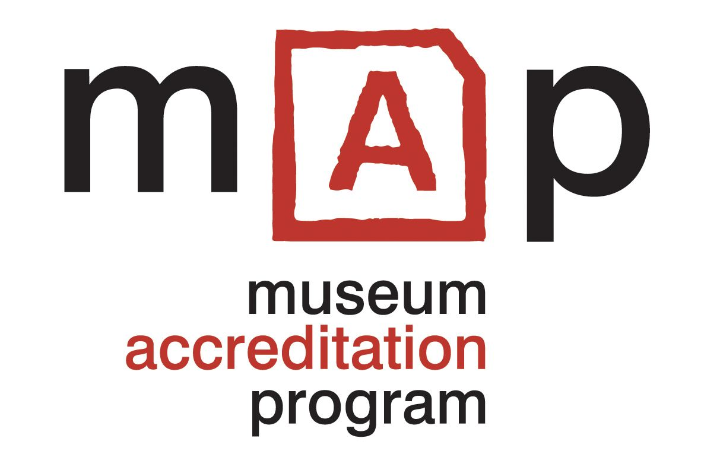
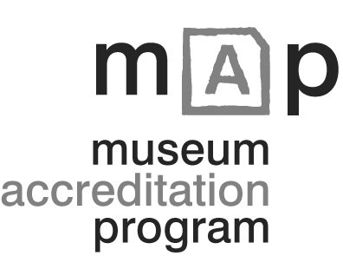

Forward Plan Template

Museums Australia (Victoria) 2007

How to use this template:

You can use this template as a reference, either to compare with an existing document, or as background reading for preparing a new document.

You can also use this template to create your own document by following the steps below.

1. Insert the name of your museum at the beginning of the document and change the title of the document and the footer at the bottom of the document (to the name you want to call the document, and the date or version of the document).

2. The governing body will need to read the explanatory notes and examples (these are shaded in the template), discuss each section and formulate the key points for your museum.

3. The template can then be typed into directly under the relevant section. Press the ‘insert’ key before you start each line and the underlining will disappear as you type. There is no typing limit but the lines give an indication of how much space you might allocate for each section.

4. Finally, delete all the instructions in the shaded areas.

Notes

- The examples (in italics) help explain what each section is about; your own information will be unique to your museum and may be very different to the example provided.

- You may wish to make changes to the template e.g. change terminology or re-order or re-group information to suit the way you do things – as long as the sections are covered you can create a useful guiding document for your museum which meets recognised museum standards.

FORWARD PLANNING TEMPLATE
Museums Australia (Victoria) 2007

1. STATEMENT OF PURPOSE

What we are here to do?

(Can also be known as mission)
Your statement could consider:
- The primary reason for creating the museum
e.g. To preserve the gold mining history of the area for future generations

- The functions of the museum
e.g. The collection, preservation and interpretation of objects and documents relating to the gold mining era

- The geographical area covered
e.g. Ballarat and district

- The subject speciality of the museum, if applicable
e.g. Gold mining

- The time period covered
e.g. From 1850-1880

- The method for review and amendment of the statement
e.g. By the committee every 3 years

e.g.

1. Immigration Museum Mission
To record and interpret the immigration experience of people to Victoria and Australia, and to promote and celebrate our cultural diversity and resulting Australian identity.

2. Suggested basis for a museum mission
The (name of museum) is a source of knowledge, ideas, stories and memories. It is developed and managed as a community resource to inspire, educate and inform the community and visitors and to contribute to the conservation of the history and heritage of the district (or subject of the museum). (Kylie Winkworth, MGnsw Collection Policy Template 2005)

_______________________________________________________________________

_______________________________________________________________________

_______________________________________________________________________
2. SWOT ANALYSIS
The current situation for the museum.
What are the things you do very well? What are your strong points? What are the things that you could improve, or that are problems for you? What additional opportunities could you explore? What are the key threats to your continuing to operate?

STRENGTHS | WEAKNESSES
OPPORTUNITIES | THREATS
3. LONG TERM GOALS

Where do we want to go?
Write a brief description of the key things you would like to see happen in the next three to five years.
You do not have to go into great detail, but you should show that you are thinking about things you would like to achieve over the next five years. Include both existing activities that you plan to continue and any improvements or new projects you are planning.

To define your goals think in terms broad categories such as:

- exhibitions/collection
- programs and services
- building and facilities
- marketing, promotions, visitor development
- finances, fundraising and sponsorship
- staffing and volunteers

_______________________________________________________________________

_______________________________________________________________________

_______________________________________________________________________

_______________________________________________________________________

_______________________________________________________________________

_______________________________________________________________________

_______________________________________________________________________

_______________________________________________________________________

_______________________________________________________________________

_______________________________________________________________________

_______________________________________________________________________

_______________________________________________________________________

_______________________________________________________________________

4. SHORT TERMS GOALS

Short-term goals are the things you plan to achieve in the next twelve months.
They will need to be specific and detailed. Include both existing activities that you plan to continue and any improvements or new projects you are planning. See Long Term Goals for list of categories to consider.

_______________________________________________________________________

_______________________________________________________________________

_______________________________________________________________________

_______________________________________________________________________

_______________________________________________________________________

_______________________________________________________________________

_______________________________________________________________________

_______________________________________________________________________

_______________________________________________________________________

_______________________________________________________________________

_______________________________________________________________________

_______________________________________________________________________

_______________________________________________________________________

_______________________________________________________________________

_______________________________________________________________________

_______________________________________________________________________

_______________________________________________________________________

_______________________________________________________________________

5. ACTION PLAN GUIDELINES

How do we get there from here?

Now list your short term goals in the ‘Activity’ box, and work out how long it should take, who will do it, how much it is likely to cost and how you will decide if the goal has been achieved.
e.g.

Activity | Timeframe | Responsibility | Budget | Success Indicator
Undertake visitor research using Arts Victoria’s Visitor Research survey | 1st 2 weeks of April and Oct. | Margaret and Steve | $10 (printing) | Complete surveys and analyse results, prepare report to include in annual report
Develop program for school activities | 3 months  Feb-April | Joan with help from PS | $100 printing, design | New worksheets for primary school visitors for 3rd term 2007
Articles in local newspaper to attract volunteers, hold info night for potential volunteers, catering by existing members | ongoing | David with all committee | $25 for coffee, etc. | Two articles in newspaper, one evening function, recruit four new volunteers

How will we know if we're successful?
Success indicators (sometimes called Key Performance Indicators) are an important part of developing and achieving your goals. They should be realistic and measurable. If your goal is to "get better known" it will be very difficult to measure your success. If your goal is "set up exhibition during regional festival" it will be easier to measure your success.

5. ACTION PLAN

Activity | Timeframe | Responsibility | Budget | Success Indicator

6. DATE FOR REVIEW

When do we update the plan?

Action Plan – annually
Foward Plan – should be in 3, 4 or 5 years – choose a timeframe

What if things change?
As part of your action plan you need to schedule regular reviews of your plan to see how things are going, to make note of any changes that have occurred. Writing your Forward Plan isn't the end of the exercise; your Forward Plan is a living document and can be changed whenever needed. (Someone died and left your historical society a million dollars! It is definitely time to review your Foward Plan! Or….a new council election means your strongest supporter is no longer on Council…you need to make new friends…fast!)

Action Plan
_______________________________________________________________________

Forward Plan
_______________________________________________________________________

7. DATE OF ENDORSEMENT

Date the plan was endorsed, and the names, signatures and roles/positions of the people responsible for this

e.g.
2 December 2007 , Committee Meeting of the Brindel Historical Society
Signed Mary Rose Panas, President

_______________________________________________________________________

_______________________________________________________________________

_______________________________________________________________________

Endnote
The Forward Plan is there to be your servant, to help you focus your thoughts, encourage you, and remind you of what needs to be done and when.

