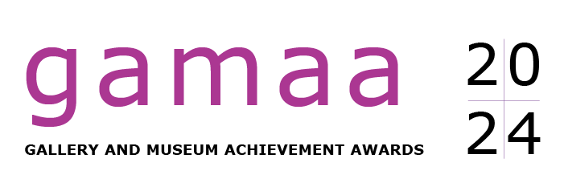
NOMINATION FORM:
INDIVIDUALS

CLOSES 5:00 PM, MONDAY 24 JUNE 2024

USE THIS FORM TO NOMINATE FOR INDIVIDUAL AWARDS

The Gallery and Museum Achievement Awards (GAMAA) are presented by Museums & Galleries Queensland to honour the achievements of individuals and organisations in striving towards excellence.

The Awards aim to:
- encourage continuous improvement and development of galleries, museums and related cultural organisations;
- enhance the profile of galleries, museums and related cultural organisations in local and wider communities;
- inspire and recognise best practice;
- recognise and encourage the contribution made by individuals to their organisations and to the gallery and museum sector.

THE 2024 GAMAA IS PROUDLY SUPPORTED BY THE QUEENSLAND MUSEUM

THE 2024 GAMAA TROPHIES ARE PROUDLY SPONSORED BY BRIAN TUCKER

THE 2024 GAMAA ARE ALSO SUPPORTED BY
PUBLIC GALLERIES QUEENSLAND AND
AUSTRALIAN MUSEUMS AND GALLERIES ASSOCIATION QUEENSLAND

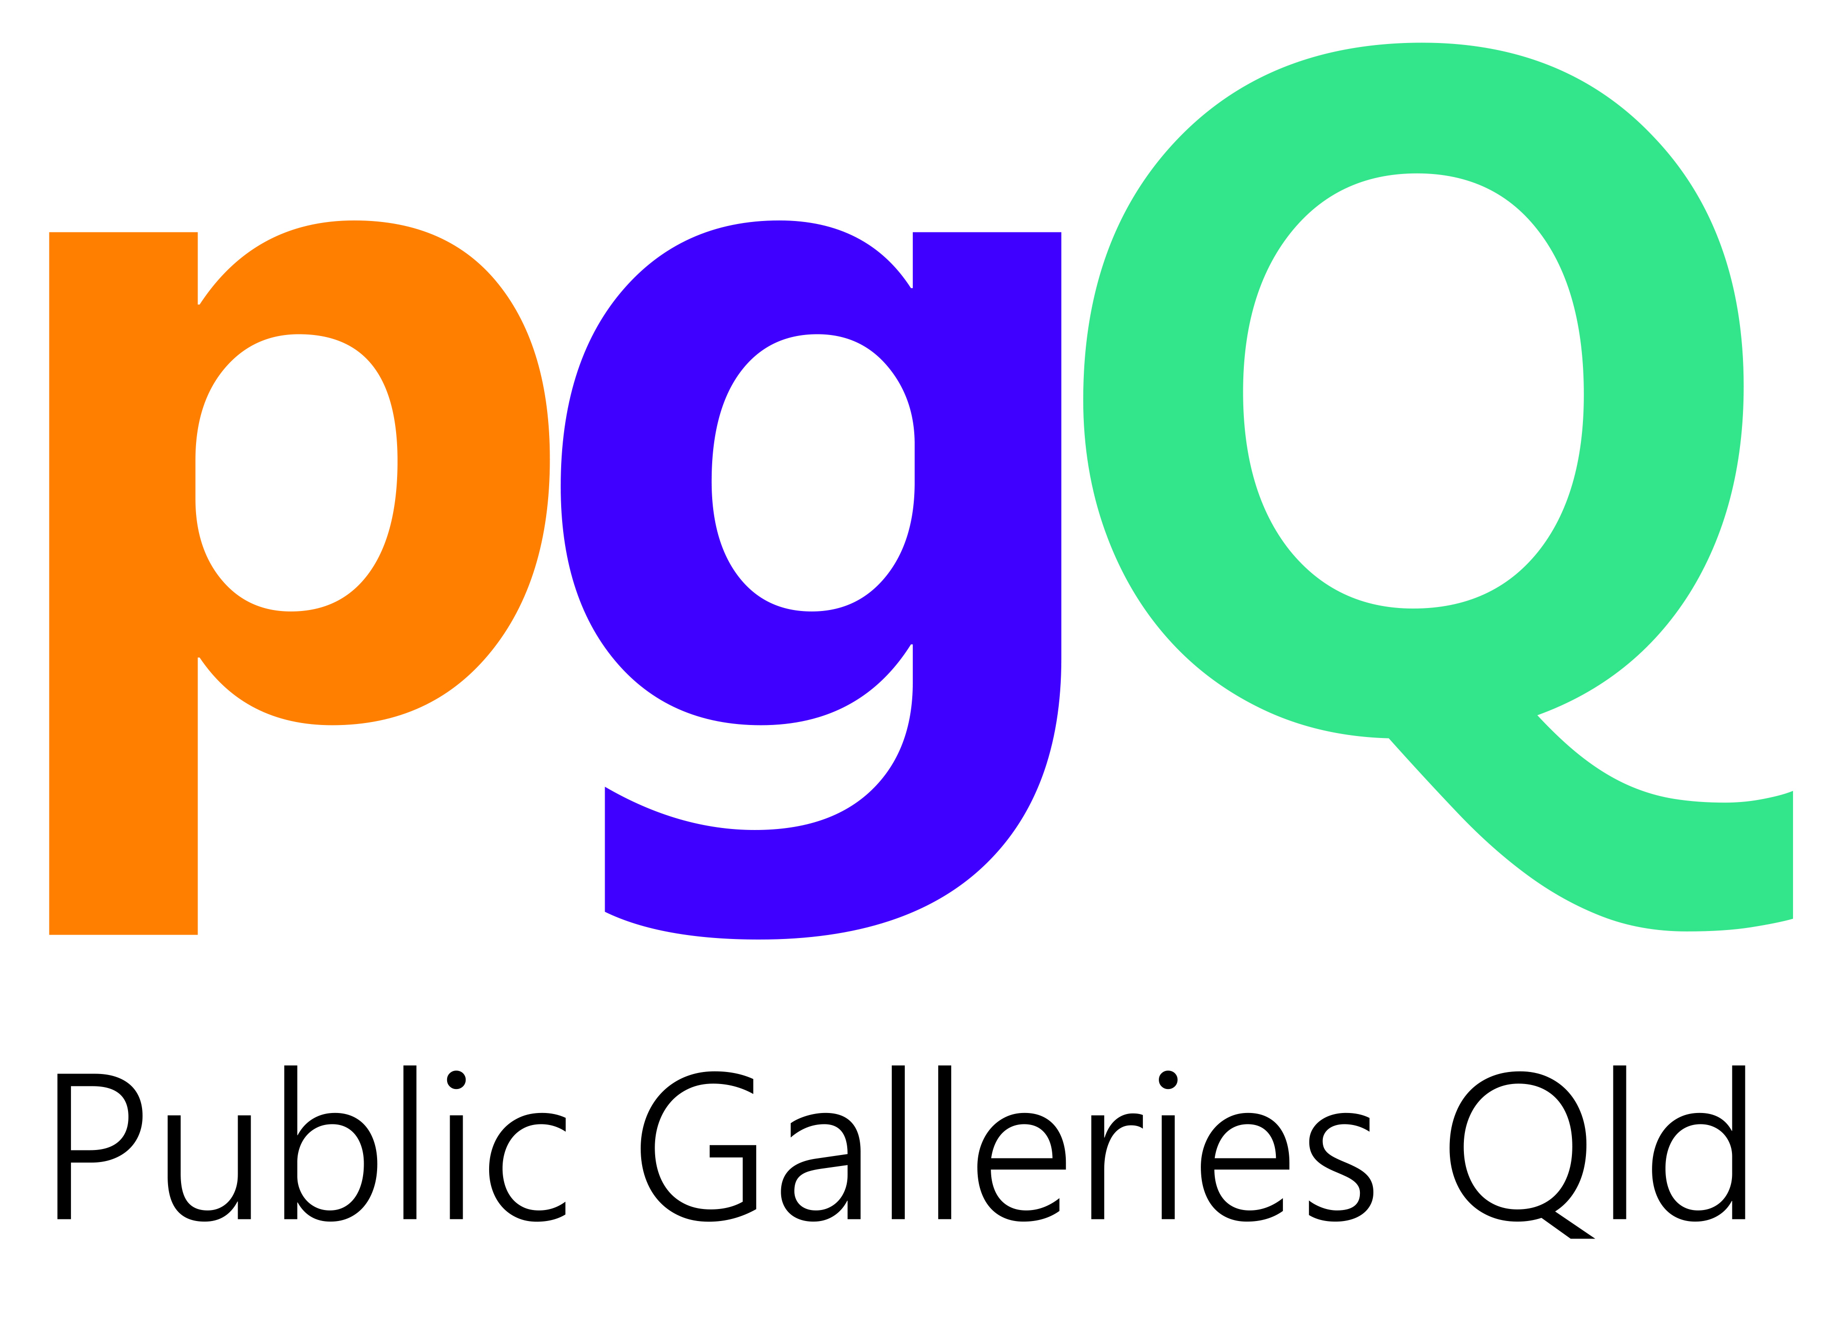

122 Gerler Road, Hendra Qld 4011 | P: 07 3059 9740 Freecall 1800 866 101 | E: information@magsq.com.au

Awards: Individuals

There are two categories for Individual Awards:

#1: Paid Staff
#2: Volunteer Staff

Use a separate form for each nomination.

An individual cannot self-nominate – they must be nominated by another person.

Nominations are invited for a paid staff member or a volunteer. In order to develop the best possible nomination and to obtain accurate facts, it is recommended that you discuss the information with the person you are nominating.

Nominations must address the selection criteria. If they do not, they will be deemed ineligible for judging.

The GAMAA will be judged by a panel of industry peers. A shortlist of Finalists in each category will be announced in August 2024.

Please discuss your nomination with M&G QLD prior to completing the nomination form.
Contact Rebekah Butler on 07 3059 9744 or freecall 1800 866 101.
We can also assist if you need help in filling out this form. The nomination form is available
in Word and PDF for you to download and complete. Go to www.magsq.com.au

There is a separate nomination form for GAMAA Organisation Awards.
Refer to the Museums & Galleries Queensland website, www.magsq.com.au
or contact M&G QLD on P: 07 3059 9740 or freecall 1800 866 101,
E: information@magsq.com.au

Criteria

The nomination should outline the person’s outstanding achievement, either for a specific activity, or for contribution/outcomes over a number of years.

You need to demonstrate how the person achieved successful outcomes – what evidence do you have?

YOU MUST ADDRESS THE FOLLOWING SELECTION CRITERIA:

- How did the person deliver outcomes that were distinctive for them?

- How did the person raise their own standards of practice and/or increase the level of professionalism of their organisation?

- How did the person enrich the cultural life of the community or have an impact on the social or economic life of the community?

For example:
Did the person deliver successful outcomes in one or more of the following ways:

  - educate audiences or encourage life-long learning;
  - work with new communities or new audiences;
  - develop new partnerships to improve their or their organisation’s practice;
  - increase community engagement and participation;
  - increase community wellbeing;
  - achieve successful outcomes for specific groups within the community (e.g. children/youth, families, women, men, older people, Aboriginal or Torres Strait Islander peoples, people with disability, people with neurodiversity, people from culturally and linguistically diverse backgrounds, LGBTIQ+ people, people who are isolated or disadvantaged)?

- How did the person provide inspiration as a role model for others or lead others to implement new ideas, directions or initiatives?

Guidelines

ELIGIBILITY

The nominated individual must be located within Queensland.
The nomination must be for one person and must be received on this form. (Forms are also available to download as a ‘fillable’ PDF or as a Word document for word processing.)
Nominations must be received by 5:00 pm on Monday, 24 June 2024.

Nominations will be accepted for an individual paid staff member or a volunteer of any of the following:
- Public/non-commercial museums and galleries.
(Individuals from privately-owned museums and galleries that are not-for-profit are eligible to be nominated.
Individuals from other privately-owned museums and galleries may be eligible to be nominated if they can demonstrate that their organisation operates in a public, non-commercial manner. If in doubt, phone M&G QLD to confirm eligibility before you begin the nomination form.)
- Indigenous Keeping Places or Cultural Centres.
- Cultural networks where the nominated activity has an outcome related to exhibitions or museum practice.
- Arts councils where the nominated activity has an outcome related to exhibitions or museum practice.
- Artist-run spaces where the nominated activity has an outcome related to exhibitions or museum practice.
- Libraries where the nominated activity has an outcome related to exhibitions or museum practice.
- Online activities related to exhibitions or museum practice.

If in doubt, please confirm your eligibility by phoning Rebekah Butler at M&G QLD on
07 3059 9744 or freecall 1800 866 101.

TIME FRAMES

The work of individual nominees may date back a number of years.

Guidelines … continued

NOMINATION FEES

*Australian Museums and Galleries Association (AMaGA) members — Free
*Public Galleries Queensland (PGQ) members — Free
A non-refundable fee of $30 per nomination applies to all other nominations (contact M&G QLD to arrange).

*For free entry, the person being nominated, or the person submitting the nomination, or either of their organisations, must be an AMaGA or PGQ member. If you need to check your membership status, email membership@magsq.com.au or phone the freecall number 1800 866 101.

SUPPORT MATERIAL

Nominations should be accompanied by up to four items of support material. Material should be succinct and clearly related to the person nominated. It should enhance your written nomination by giving additional information or backing up the claims you have made. You are encouraged to submit up to the maximum number of items – providing good-quality support material will help to strengthen your nomination.

Here are some examples to get the best out of your support material:

- Each media clipping counts as 1 piece of support material, so don’t send two or three that say the same thing. Choose the best.
- A maximum of 10 photos counts as 1 piece of support material (please send each photo as a separate file).
- Judges will not have time to read every word of large publications (including catalogues, education kits etc), so identify particular sections you want them to see.
- Don’t supply a 3-hour film – choose one or two excerpts of no more than 5–10 minutes’ duration.
- You can choose to send a written referee’s report as one of the items. Make sure it adds to what your nomination says, not simply repeats the same information.

Where possible, support material should be provided electronically (e.g. scans of media clippings, jpg files of photographs) by either email; posted on a USB drive; or sent via Dropbox (or similar). Nominations will not be disadvantaged where this is not possible.
Catalogues, publications etc. can be mailed in hard copy.

Guidelines … continued

REFEREES

Contact details of two referees must be included on this nomination form. Where possible, you should try to use referees who can speak with knowledge but also be objective about the person nominated. Ensure that your referees know that you have supplied their details.
Generally, the judges will only use referees where they need to verify the accuracy of information on the nomination form, or where the judging scores are close and additional information will assist with the decision-making.

SUBMISSION OF NOMINATIONS

Use a separate form for each nomination. You can send your nomination and support material by:

EMAIL: Send the nomination form attached as a PDF file, with support material, to: information@magsq.com.au
Try to keep the files at a reasonable size (no larger than 10MB per email).

Any material that can’t be emailed (e.g. large publications) can be sent by mail. Indicate which method you are using on page 11.

POST: You can either send a hard copy of the completed nomination form and support material or save it all to a USB drive and post to:

MUSEUMS & GALLERIES QUEENSLAND
122 GERLER ROAD, HENDRA QLD 4011

Hard copy nomination forms should be simply presented and clipped together. Please do not bind or use special graphics, folders etc.

DROPBOX (or similar): Contact us for details.

If you experience difficulty submitting your nomination by any of the above methods, please contact us on P: 07 3059 9740 or freecall 1800 866 101, E: information@magsq.com.au

NOMINATIONS MUST BE RECEIVED BY 5:00 PM ON MONDAY, 24 JUNE 2024.

Individual’s Details

Individuals must be nominated by another person.

I nominate the individual listed below for the 2024 Gallery and Museum Achievement Awards, in the following category:

(If you are completing this form in Word, you can double-click on the appropriate box and when the menu comes up, in the right-hand corner, select ‘Checked’.)

Category #1: PAID STAFF
Category #2: VOLUNTEER STAFF

Name of individual being nominated ……………………………………………………………………………………
Name of individual’s organisation (if applicable) ……………………………….……………………………………………
Individual’s position in organisation (if applicable) ………………………………………………………………………….
Contact details for the individual being nominated:
Phone ………………………………………………… Email …………………………………………………………………………
Address ……………………………………………………………………………………………………………………………………….
Name and contact details of the person submitting this nomination
Your name …………………………………………………………………………………………………………………………………..
Name of your organisation (if applicable) ……………………………….……………………………………………………….
Your position in organisation (if applicable) ………………………………………………………………………………………
Contact phone ……………………………………………….. Email ………………………………………………………………
Address ……………………………………………………………………………………………………………………………………….
Signature* …………………………………………………………………… Date ……………………………………………….

*You can type your name which will be deemed to represent your original signature.

Are you, or the nominated individual, or either of your organisations, a member of AMaGA or PGQ?   No   Yes: Membership Number: …………………

Nomination

If using word processing, the font size must be no smaller than 10 point.

WHY ARE YOU NOMINATING THIS PERSON?
Please note that in the next section you will be asked to outline this person’s outstanding achievement against the selection criteria.
Please use this page to give a general overview of the person’s position or role in their museum, gallery, or the cultural sector, including a brief outline of whether you are nominating this person for a specific activity, or for their contribution/commitment over a number of years.
Maximum one A4 page.

Nomination … continued

If using word processing, the font size must be no smaller than 10 point.

HOW DOES THIS PERSON’S ACHIEVEMENTS MEET THE SELECTION CRITERIA?
Maximum two A4 pages. (Attach the additional A4 page if required.)
Go to page 3 for the selection criteria.
Give clear examples to describe the person’s outstanding achievement.
Nominations will be deemed ineligible for judging if they do not address the criteria.

Referees

Nominations must include the details of two referees who can be contacted to comment on the nomination if required. A written referee report can be included as part of the four items of support material if desired.

Name of Referee 1: …………………………………………………………………………………………………………………

Title / Position / Relationship to Nominee: ……………………………………………………………………………….
………………………………………………………………………………………………………………………………………………………
Contact phone ……………………………………………….. Email ………………………………………………………………
Address ……………………………………………………………………………………………………………………………………….

Name of Referee 2: …………………………………………………………………………………………………………………

Title / Position / Relationship to Nominee: ……………………………………………………………………………….
………………………………………………………………………………………………………………………………………………………
Contact phone ……………………………………………….. Email ………………………………………………………………
Address ……………………………………………………………………………………………………………………………………….

Support Material

SUPPORT MATERIAL IS LIMITED TO UP TO FOUR ITEMS.
See page 5 for notes on support material.

Where possible, support material should be provided electronically (e.g. scans of media clippings, jpg files of photographs) by either email; posted on a USB drive; or sent via Dropbox (or similar). Nominations will not be disadvantaged where this is not possible.

If your nomination is a Finalist, you consent to M&G QLD using the support material that you provide at the Awards evening and in publicity. You must ensure that you have appropriate permissions to use the images you have provided. Please provide captions for images and acknowledgements (photographer credits, etc.) where relevant.

Complete a description of the support material submitted with this nomination.

DESCRIPTION OF SUPPORT MATERIAL: Indicate how you are providing this material:

Email USB Hard copy Dropbox
attachment mailed mailed or similar

1. …………………………………………………………………………

2. …………………………………………………………………………

3. …………………………………………………………………………

4. …………………………………………………………………………

Check List

Before sending in your nomination form, please ensure that you have all the correct information. Use this check list as a guide.

Have you discussed your nomination with staff from M&G QLD?
Have you included only one nomination on this form?
Have you addressed the criteria? Nominations will be deemed ineligible for judging if you have not done so.
Have you included the names of two referees?
Have you listed your support material?
Have you limited your support material to four items?
Are you, or the nominated individual, or either of your organisations, a member of AMaGA or PGQ?
If you, or the nominated individual, or either of your organisations, are not a member of AMaGA or PGQ, have you arranged to pay the nomination fee?

If you have any questions about the guidelines or nomination form, please contact Rebekah Butler on 07 3059 9744 or freecall 1800 866 101 for assistance.

THANK YOU FOR TAKING THE TIME TO SUBMIT A NOMINATION FOR THE 2024 GALLERY AND MUSEUM ACHIEVEMENT AWARDS.

We appreciate your effort and wish you well in the judging.

NOMINATIONS MUST BE RECEIVED BY 5:00 PM ON MONDAY, 24 JUNE 2024.

SEE PAGE 6 FOR INSTRUCTIONS ON SENDING YOUR NOMINATION FORM AND SUPPORT MATERIAL.

